Health Informatics Centre
Recruitment Tracker
User Guide

1. General 2
1.1. Accessing the HIC Recruitment Tracker 2

2. Getting Started 3
2.1. Logging in 3
2.2. Selecting a Project 3
2.3. Navigation Bar 4
2.4. Site-wide Functions 4

3. Project Summaries 5
3.1. Identified For Study 5
3.2. Awaiting GP Response 5
3.3. Letter Sent 6
3.4. Agreed To Be Contacted 6

4. Patient Management 7
4.1. Adding Patients 7
4.2. Finding Patients 8
4.2.1. Filters 8
4.2.2. Searching 9
4.2.3. Advanced Searching 9
4.3. Viewing & Updating Patients 10
4.3.1. Additional Questions 10
4.3.2. Appointments 11
4.3.3. Letters 11
4.3.4. Audit 11

5. Appointment Management 12
5.1. Viewing and Creating Appointments 12
5.2. Availability Manager 15
5.3. Appointment Sheet 17
5.3.1. Appointment Views 18
5.3.2. Download as Word document 19

6. Project Information 20
6.1. Basic 20
6.2. Additional Questions 20
6.3. Statuses 21

General

Accessing the HIC Recruitment Tracker
The HIC Recruitment tracker is available from any PC with an Internet connection.
To access it, simply follow this link:
https://hicservices.dundee.ac.uk/recruitment/

Getting Started

Logging in
On the login page, log in to your account using the username and password provided by HIC.

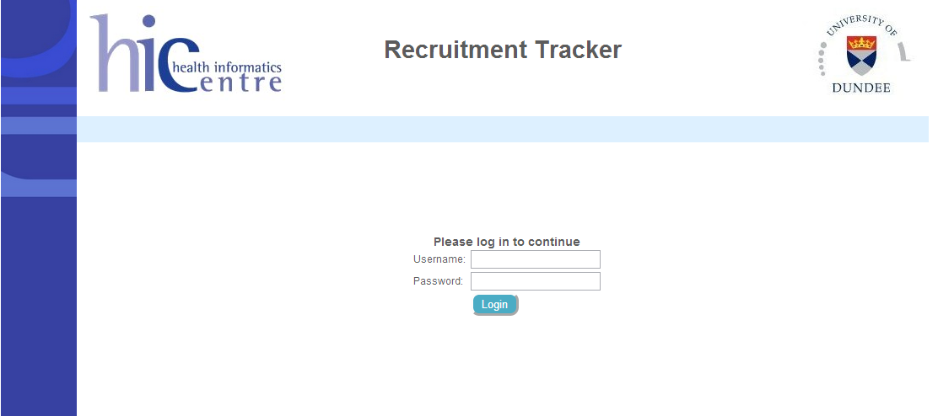
Login screen

Selecting a Project
Once logged in, you will have access only to your project data. There could be multiple projects in the list but typically there will only be one. Select the project you want to view by clicking on ‘Open’ beside the project.

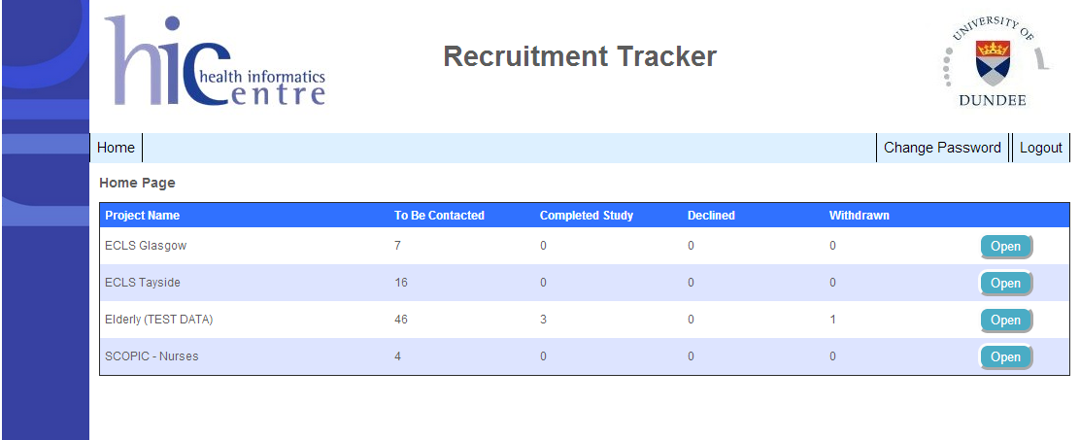
Displaying all projects that a user can access

Navigation Bar
The navigation bar is shown at the top of the recruitment tracker, and is used for the main navigation through the application. Your navigation should look similar to below:

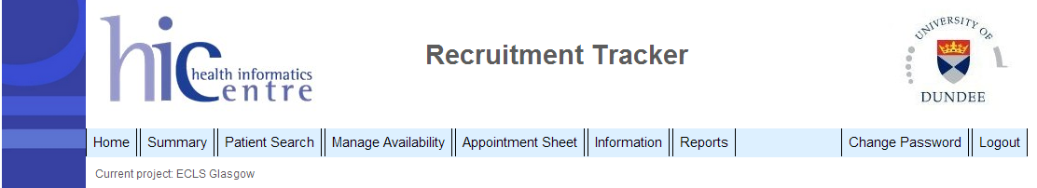
The navigation bar

Some features are dependent on the project that you’ve selected (displayed just below the navigation bar), for example, ‘Manage Availability’ and ‘Appointment Sheet’ will only be present if the project requires the use of appointments, similarly with ‘Reports’ – only used by projects which use reports. An ‘Admin’ button will be available if you are logged in as an administrator.

Site-wide Functions
Using the navigation bar (see above), you can do the following at any time:
- Logout by clicking on the ‘Logout’ link at the right
- Return to the Project List by clicking ‘Home’ at the left
- Change your password by clicking ‘Change Password’ near the right

Project Summaries
Once you have selected a project, you will be taken to the project summary page.
This page displays some reports of the project’s current status.
This page is accessible at any time by clicking ‘Project Summary’ on the navigation bar.

Identified For Study
This shows how many people have been identified as suitable participants. Not all these people identified will agree to be part of the study. The number of ‘Positive’ participants is the number of people who have agreed to take part. These are people whose details you will be able to view/update, and also those summarised under ‘Agreed to be contacted’.

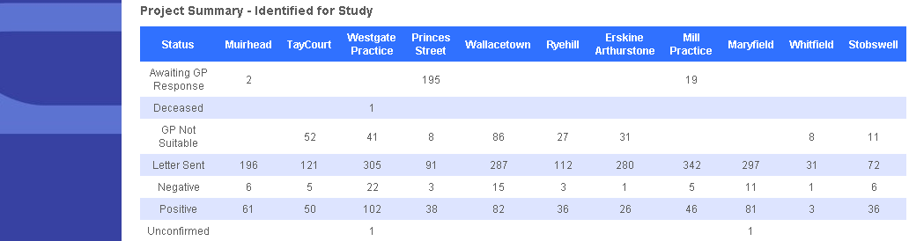
Summary of those identified for the study

Awaiting GP Response
This report goes into more detail for those at the GP awaiting status. It displays number of patients by their practice, and when the list was sent.

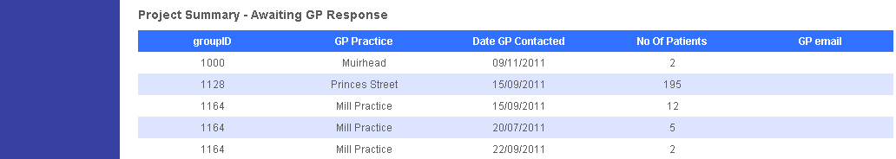
Summary of those who are awaiting a GP response

Letter Sent
This lists data about letters that have been sent out to patients within different groups, including the number of patients letters were sent to, and the date of the first letter sent.

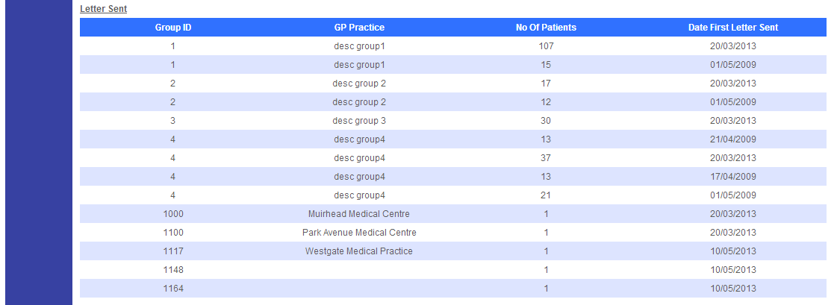
Summary of those who have had letters sent to them

Agreed To Be Contacted
This summary grid shows how many people are at each of your status within your project. This is a summary of the data that you control. The status ‘To Be Contacted’ is the initial status and is ordinarily the only status that will be set by HIC. This indicates newly recruited people who HIC have recently received a positive response slip for and whom the research team have not yet tried to contact. These status are customised on a per project basis, but it might show who has completed the study, who has visit 2 booked, who is waiting for blood results, who is declared unsuitable after initial visit etc..

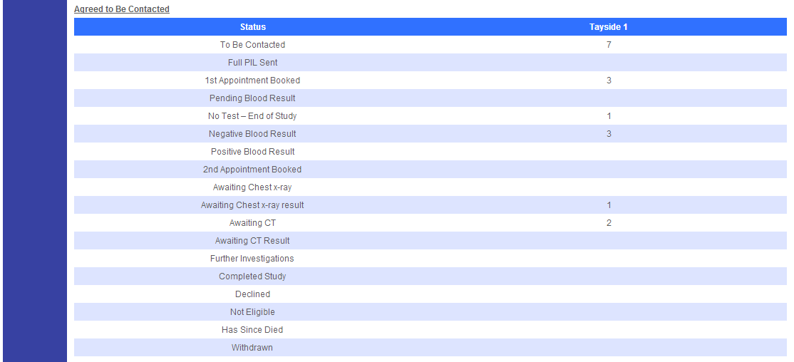
Summary of those who have agreed to be contacted

Patient Management

Adding Patients
To add a new patient, click on the Add New Patient button, located next to the Search and Clear buttons. This button is only visible if you have permission to add new patients to the project.
This will display the entry screen for a new patient record:

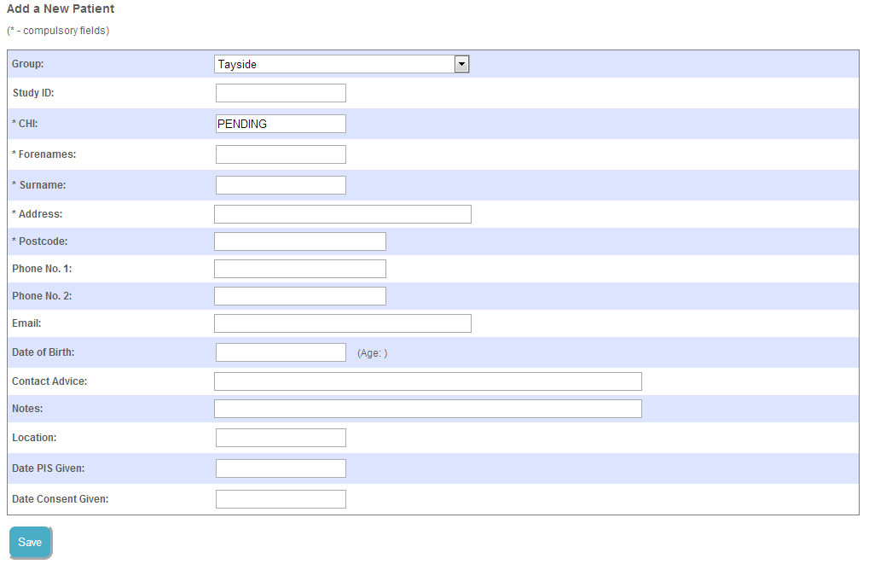
Adding a new patient

You must enter the patient’s CHI number, forenames, surname, address and postcode. You may also enter the study ID, phone number, email, date of birth, date patient information given, date consent given, notes, contact advice and location. If you enter a date of birth, the patient’s age will be calculated automatically.

Once you have finished entering the patient’s details, click the Save button to save the record and go to the newly created patient details page.

Finding Patients
This page is accessible at any time by clicking ‘Patient Search’ on the navigation bar.
This page allows you to view and update individual patient’s records. These are patients who have agreed to be contacted by the research team for the study. Only the first 10 patients will appear on the screen, to view the next 10, use the numerical navigation links at the bottom of the page. Page 1 will display the first 10 patients, Page 2 the second and so on.

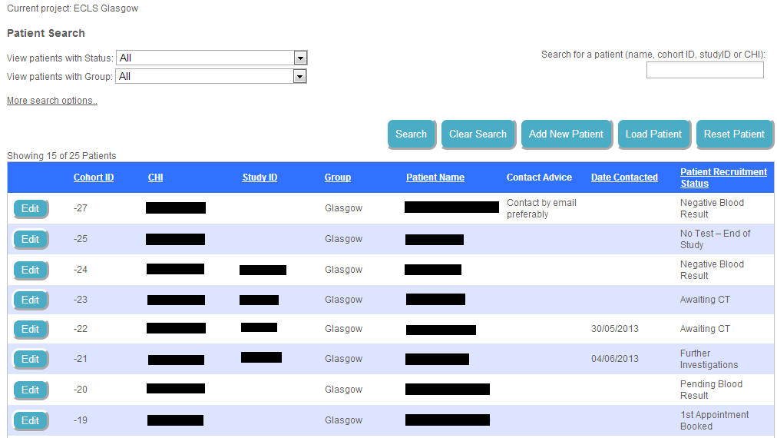
Patient Search showing the first 15 of 25 patients

Filters
If you want to view everyone with a certain status or in a specific group you can filter the cohort for this. To do this, select from the drop down lists next to “View patients with Status/Group”.

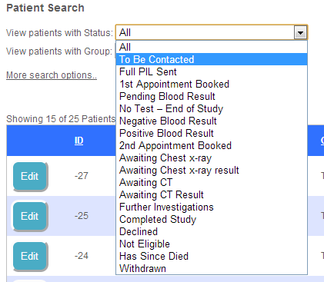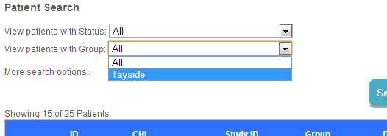
Filter by Status | Filter by Group

Searching
To search, simply enter all or part of the required patient name, ID, study ID, group or status.

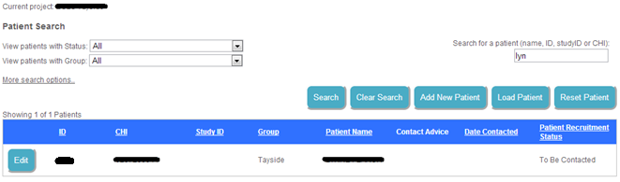
Searching for ‘lyn’, 1 result found

Advanced Searching
To access the advanced search options, click the “More search options..” link, below the status and group boxes. This will give you the option to add a search item which will be one of postcode, contact advice, date contacted, location, address, notes, or any of the additional questions that may be associated with the project.

You can add as many individual searches as you wish; each search works like an ‘and’ – for example if you have two searches chosen, one for a postcode of ‘DD1’ and the other for a date contacted of ’21-11-2012’ will give a result set of people who have a postcode containing ‘DD1’ AND a contact date of ’21-11-2012’, not one or the other.

The advanced search can be used at the same time as the main search or group/status filters. The main search and filters will be used first, and then the advanced searches are applied to the results – giving some good search flexibility.

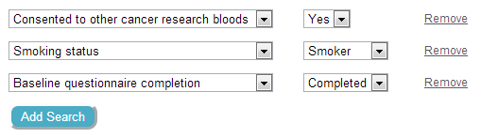
Searching for smokers who have completed their questionnaire,
and who have consented to blood research

Sorting Results
Once you have searched for a set of patients, you can sort them in order of any column. Simply click on the header of a column to sort the contents; click again to sort the other way (ascending/descending).

Viewing & Updating Patients
To update a specific patient record, click on the edit button to the left of the patient’s record on the Project Details page (see section 5). This will display the full patient record.

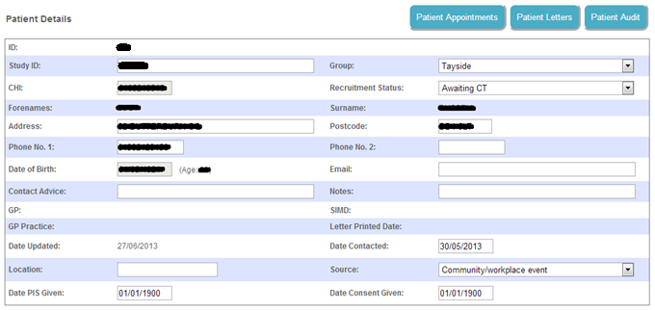
Patient details

Using this page, you can update the majority of the patient’s information, including their recruitment status, address, and group. You can save your changes by clicking ‘Update’ at the bottom of the form. If the patient has a status that means they are closed, this form will be un-editable (however you will still be able to view it).

Additional Questions
If the project supports them, there may be a section of additional questions that can be answered.

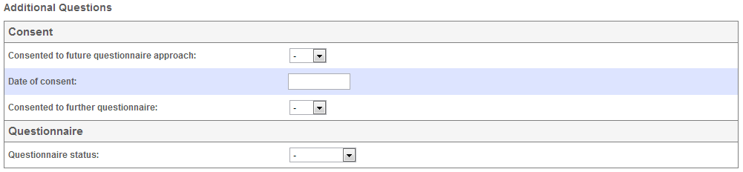
Additional questions

Additional questions are grouped by their topic (such as ‘Consent’ or ‘General’), which may differ from project to project. You can save any changes to these using the same button as the main form.

Appointments
Access the selected patient’s appointment information by clicking ‘Patient Appointments’ at the top of the details page.

This page shows all appointments associated to the patient, and lets you add appointments. This functionality will be covered in the Appointment Management section of this user guide.

Letters
Access the selected patient’s letters by clicking ‘Patient Letters’ at the top of the details page.
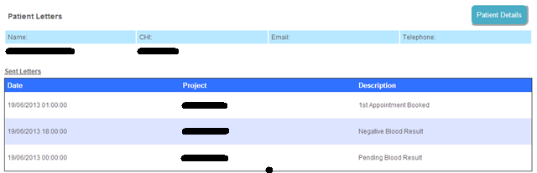
Letters sent

The letters page shows any letter that has been sent to the patient, along with the reason that the letter was sent and the date. Again, you can return to the patient details page by clicking the ‘Patient Details’ button at the top of the page.

Audit
Access the selected patient’s audit trail by clicking ‘Patient Audit’ at the top of the details page.

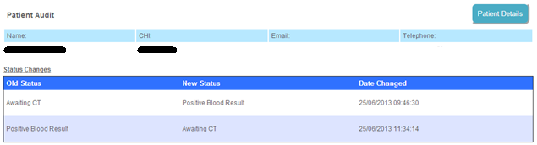
Audit trail for changes in status of Lucy Russell

The audit trail shows any changes that have been made to the patient’s status and the date at which the changes were made. You can return to the patient details page by clicking the ‘Patient Details’ button at the top of the page.

Appointment Management

Viewing and Creating Appointments
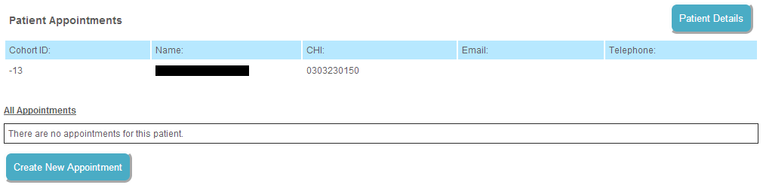
Appointment information (no appointments yet)

To access the appointment functions, you must first select a patient and enter their details page (see the Patient Management section of this user guide). This page shows information about all appointments for the selected patient, including the nurse it’s with, the date/time and location, type of appointment, and its status. You can either create a new appointment (if the patient isn’t closed), or select an appointment to see more information. At any time you can return to the patient details page by clicking the ‘Patient Details’ button at the top of the page.

To create an appointment, click the ‘Create New Appointment’ button to go to the scheduler.

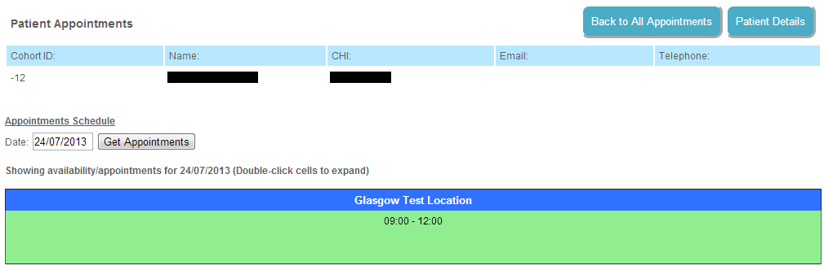
Appointment Scheduler

Choose a date to add an appointment to by using the date box and clicking ‘Get Appointments’, this will bring up all available locations on that date in green. Double click within a green area to expand it and start adding an appointment.

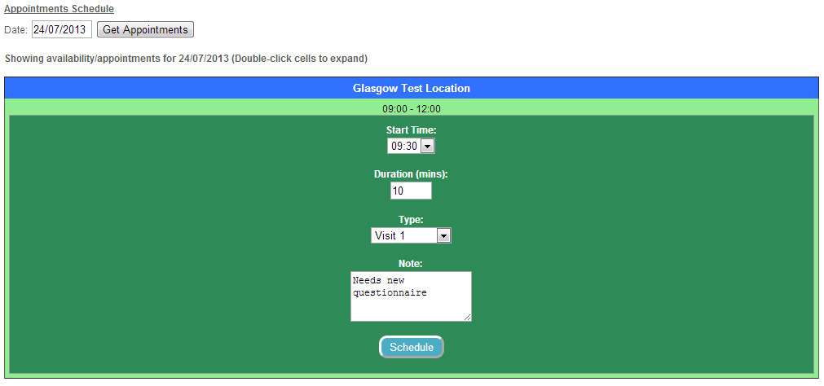
Adding an appointment

Enter the relevant information into the new appointment box (you can increase the size of the notes box by clicking and dragging the bottom-right corner), and click ‘Schedule’ to add the new appointment to the system. An error will be shown if there are any problems, if not, the schedule will retract back down and the appointment will be added. Appointments on the scheduler will appear in blue.

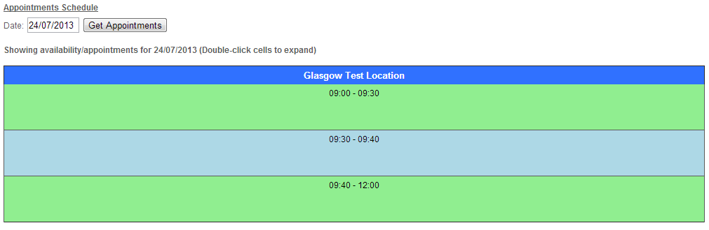
Appointment scheduler after an appointment has been added

Similarly to the available spaces, the appointments can be double clicked to expand them – displaying information about that specific appointment, and also providing a way to cancel the appointment.

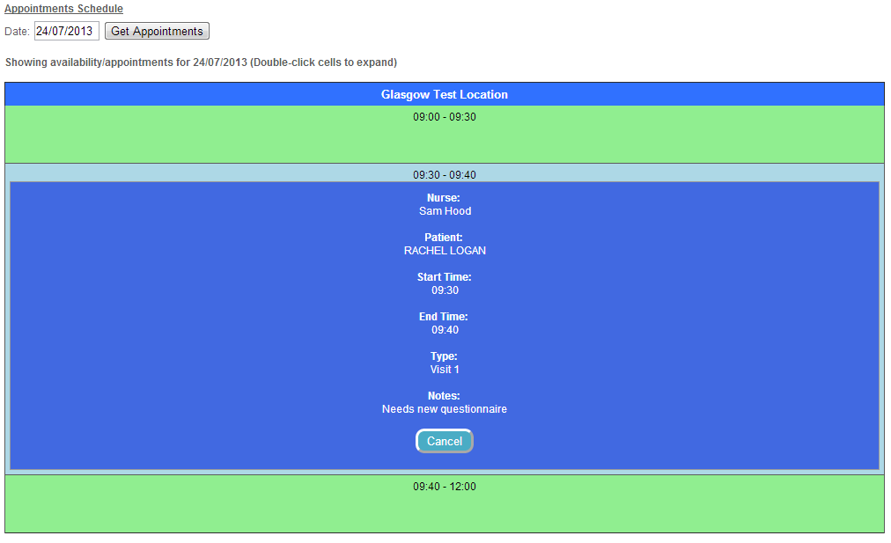
Appointment information with ability to cancel

Return to the appointment page by clicking the ‘Back to All Appointments’ button at the top right, this will now show the appointment that has been added.

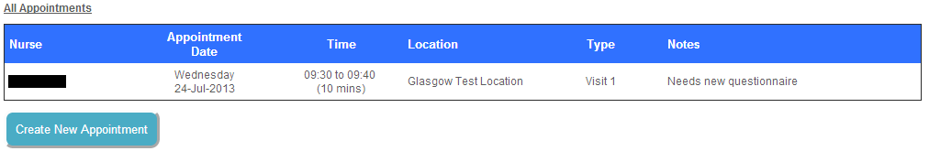
Appointment displayed on appointment page

Availability Manager
The availability manager is used to schedule and cancel nurse availability at locations. It can be accessed by clicking ‘Availability Manager’ in the navigation bar.

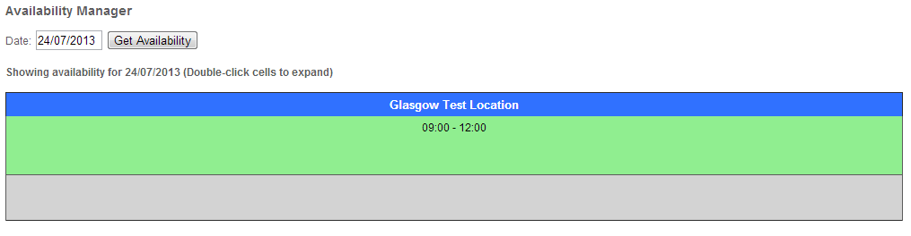
Availability manager showing one availability slot

Similar to the appointment scheduler, double clicking on a section will expand it. As shown in the above image, there is some availability already scheduled for 09:00 to 12:00; expanding this will show any appointments and availabilities that exist within it. Any additional locations would be displayed as extra columns in this view.

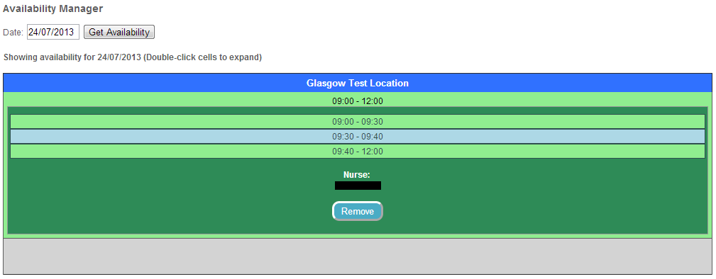.
Contents of the availability – shows one appointment (09:30 – 09:40)

Appointments are shown in blue, availability in green, giving a good overview of how busy a certain availability slot is. To remove an availability slot, simply click the ‘Remove’ button – note that an availability slot cannot be removed if it contains an appointment; you must first remove the appointments through the appointment scheduler.

To add an availability slot, double click on the grey area on the availability manager to expand the cell. This will give you some options to fill out before creating the availability slot.


Controls to add availability slot

Once you are happy with the availability settings, click ‘Add’ to create the slot. The system will not allow availabilities to overlap within the same location and will display an error. If all goes well you should see the availability slot added to the manager, and will now be available to add appointments to in the appointment scheduler.

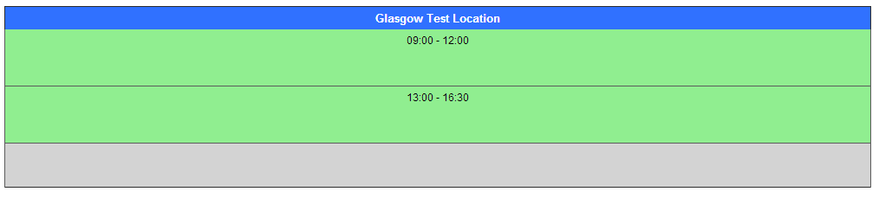
Newly added availability slot

Appointment Sheet
Open the appointment sheet from the menu at the top of the page (this will only available for projects where appointments are in use).

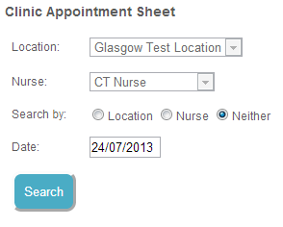
Controls for the appointment sheet

Using the controls, you can generate several different versions of the appointment sheet. The grid (shown under 5.2.1-3) contains blocks representing appointments, and is split into 30 minute chunks. An appointment will snap to the 30 minute chunk that it starts in (e.g. A start time of 13:15 will be shown to begin in the 13:00-13:30 chunk).
Each appointment block provides the patient’s name and contact number, nurse attending the appointment, time and duration of the appointment, and location (as well as any comments).

Appointment Views
Click the ‘Location’ radio button and then choose a location from the drop down (marked ‘Location’). Then select a date by clicking the date box and choosing from the calendar pop-up.
When you are happy with the selection, click ‘Search’ to generate the appointment sheet based on location:

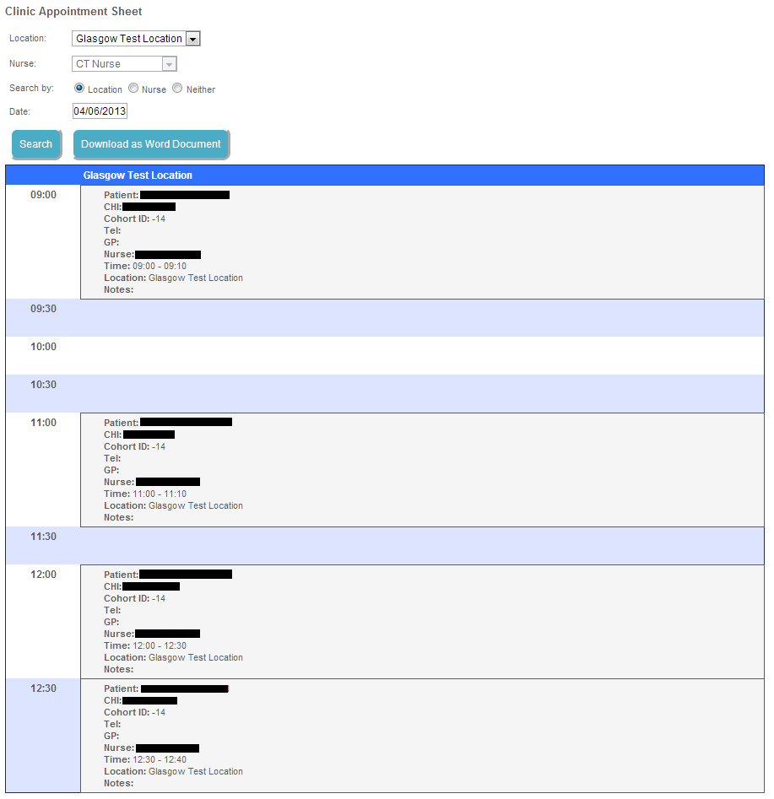
Appointment sheet for location ‘CRC1’ on 04/06/2013

Go through exactly the same steps, except selecting the ‘Nurse’ radio button and choosing from the nurse drop down to get an appointment sheet based on a nurse for a particular date. The nurse view will be the same as above.

To see an appointment sheet for the entire day, regardless of nurse or location, click the ‘Neither’ radio box, which will search for neither locations or nurses, just everything for the given day, this will give you a slightly different view in that it breaks the appointments up by location, and puts them in their own columns.

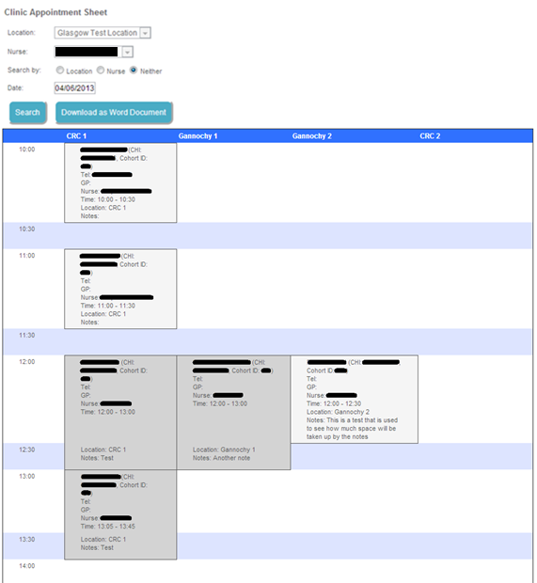
Appointment sheet for all appointments on 04/06/2013
(The ‘CRC2’ appointments appears further down the sheet)

Download as Word document
All appointment sheets (with the exception of empty ones) can be downloaded as a Microsoft Word document by clicking the ‘Download as Word Document’ button.

Project Information
The project information page (accessed through the ‘Information’ link on the navigation bar) is used to find out various details about the project you are accessing.

Basic
Basic information covers the name of the project, and whether that project requires letters to be sent, and if it uses appointments.

Basic information

Additional Questions
The additional questions are used on the patient details page for projects that require more questions than the default ones provide. Listed is the question itself, along with the type of question (generally this will be the kind of control that it uses for answers; dropdown, textbox, etc.) and any default answers, which are mainly used when the type is a dropdown box, to hold the answers that will appear there. Each question belongs to a topic such as ‘General’ or ‘Consent’, these are shown as blue headers in the table below:

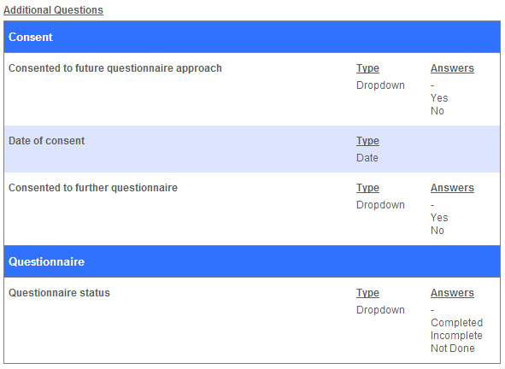
Additional questions used by a project

Statuses
Statuses are used to describe the current state of a patient, whether they are waiting to be contacted, or have just booked their first appointment. Each project uses only a subset of all statuses that exist. Some statuses determine a specific action that must be taken such as letters needing to be sent, or the patient’s record should be considered closed (or ended). These are represented by the ‘Yes’s and ‘No’s in the table.

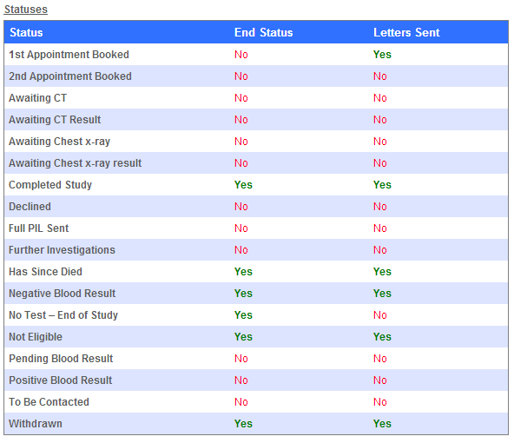
Statuses and their associated actions for a project

